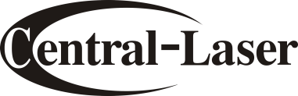
S Series Laser Marker
S系列激光打标机
Marking Without PC
无需电脑也可打标
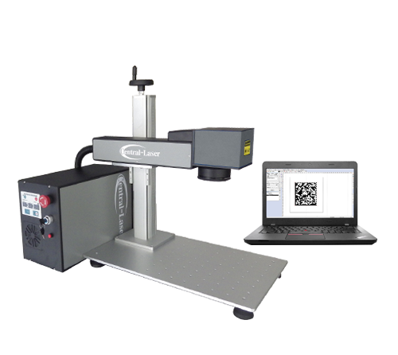

product advantages
产品优势展示

Completed I/F（接口齐全）
USB port, Rotary-axis port, Marking staus， port, Pedal port, Layer I/O（USB接口，旋转轴，打标
状态接口，脚踏开关接口，图层I/O）

Unique File Selector（独家打标选档器）
16 files, 64 layers, 1024 graphics; directly selected then mark. Record mark times. Easily
positioning with preview red beam（记忆16个档案64图层，共1024图案，直接选定后打标
记录打标次数。提供预览对位功能方便打标）

Unique galvo（创新型振镜）
CE certificate. Status indicators（创新型工作状态指示灯设计，清楚显示振镜工作状态。并获得CE认证）

Positioning Red Beam（红光定位）
Built-in red beam to get precise WYSWYG, no power loss. Support aux. focus guider,
easy to find the focal length（使用激光器自带指示定位红光，激光与红光几乎一致，打标定位精度高，且不损失功率，提供快速焦距定位红光， 打标时焦距寻找变得简单容易）

Imported nylon tube（德国料尼龙管）
Double layers seamless design. good flexibility, anti-distortion, anti-acid, abrasion resistance, bright surface（双层设计，无接缝外露。柔韧性好，抗扭曲，耐摩擦, 表面光泽鲜艳）

Precise lifter（精密升降台）
Laser marked scale: clear, green and anti-fade. Hight precise slide rails and lead screw, no tilt
and shake（高精密滑轨与螺杆制作，不倾斜不晃动。且激光雕刻刻度尺，清晰环保不退色）

Legal MARKINGMATE Software (合法的软件功能)
Support 9 different kinds of language, and cab becustomized different language by modified textfile.（九种语言可供选择，并可透过简单修改文本文件客制各种语言版本）

Provide a variety of drawing functions, such as point, line, arc, circle, rectangle, curve ... and so on.( 提供多样化绘图功能，如点、线、弧、圆、矩形、曲线等)

Can be imported dwg, dxf, Al, plt, bmp, tif, cmp,clp, cur, eps, emf, fpx, ico, wmf, psd, png, jpg.

1D Barcode: Code39, Code128, EAN8,EAN13, UCC 128, EAN 128 and FIM. 2D Barcode: DataMatrix.( 一维条形码有：Code39、Code128、EAN8、EAN13、UCC128等。二维条形码DataMatrix)

Applicable material 适用材质
Fiber laser marking machine is suitable for metal and part of non-metal materials: Nylon ABS, PVC, PES, iron, copper, aluminum, magnesium, zinc, gold, silver, coating materials, spray materials, epoxy resin etc.
CO2 laser marking machine is suitable for non-metali materials: wood, paper, leather, cloth, glass, acrylic etc.
光纤激光打标机适用：
金属及部分非金属材质：尼龙、ABS、PVC、PES、铁、铜、铝、镁、金银、镀膜材料、喷涂材料、环氧树脂等
CO2激光打标机适用：
非金属材质，竹木制品，纸张，布料皮革，有机玻璃，亚克力等

applications 应用
Used in precision machinery, jewelry, sanitary ware, watches, glasses, plastic keys, electronic components, hardware tools, mobile components, autoparts.
广泛应用于精密机械，首饰，卫生洁具，手表，塑胶按键，眼镜，电子元件，五金工具，移动通讯工具，汽车配件等

Specifications 技术参数
Model | CK-U-20 / 30 FBS
Specifications  技术规格 | 激光功率  Laser power | 20W / 30W
 | 激光波长  Wavelenth | 1064nm
 | 标准打标范围  Standard Marking Area | 110mm*110mm
 | 选用打标范围  Optional Marking Area | 70mm*70mm, 160mm*160mm, 200mm*200mm
 | 最大打标速度  Marking Speed | ≤7000mm/s
 | 最小打标线宽  Minimum Line Width | 0.02mm
 | 最小打标字号  Minimum letter | English: 0.2 x 0.2mm
 | 打标深度  Marking Depth | < 1mm
 | 打标定位精度  Location precision | ≤0.0176mm
 | 打标重复精度  Resetting positioning accuracy | 0.02
 | 电气接口  Electrical interface | support pedal switch ,I/O ,rotary-axis port
 | Precision correction of galvanometer:Precision grid calibration file（振镜精密校正，提供精密格点校正文件）
 | High Precision Digital Scan Head 10mm spot (With working status indicator light )（高精度数字振镜 (含工作状态显示灯)）
Working environment needs  工作环境需求 | 电力需求  Electrical Requirements | Ac 220V±10%.50HZ.5Amp OR , Ac 110V±10%.50HZ.10Amp
 | 供电功率  Unit Power | < 500 w
 | 可使用温度区间  Operational Temp Range | 5-40℃
 | 湿度  Operational Humidity Range | 5%-76%, Non-condensing
physical dimension  外观尺寸 | 激光头  laser head | 512*80*80mm
 | 电源箱  Chassis | 410*282*193mm
 | 净重  Net Weight | 20kg
Standard accessories | Cable length between laser head and chassis 1.7m（连接线缆长度1.7米）
 | laser googles, pedal switch, usb disk（激光护目镜，脚踏开关，U盘）
optional accessories  可选配件 | light lifter workbench Dimension: 610*160*160mm, lifting range: 90-490mm（轻型升降平板）
 | desktop light lifter, Dimension: 760*750*520mm, Lifting range: 90-490mm（轻型升降工作桌）
Rotary axis: holding range for internal jaws: 2-22mm(inside), 25-70mm(outside), external jaws: 22-63mm(inside), Concentricity:
<0.01mm（旋转轴正爪夹紧范围：2-22mm，撑开范围：25-70mm，反爪夹紧范围：22-63mm，同心径小于0.05）

產品細部圖檔
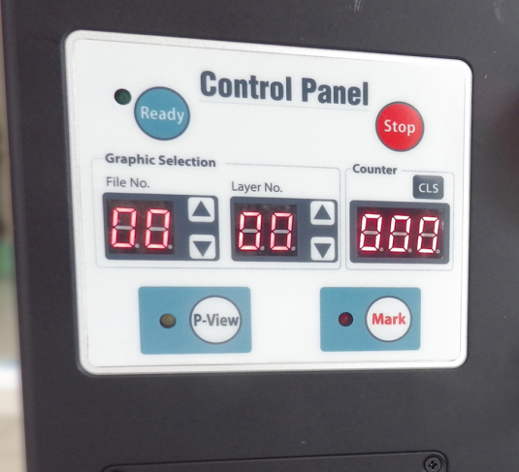
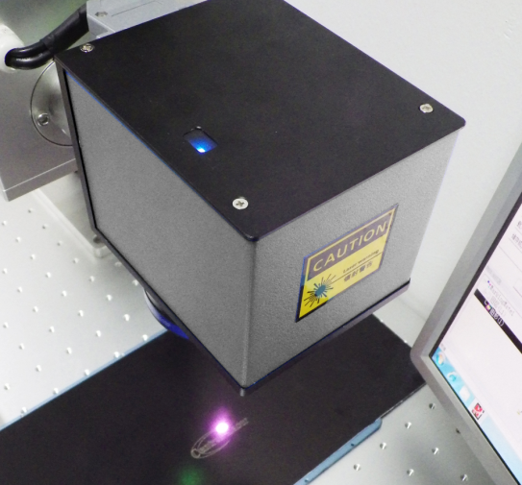

打標樣品

