• 賭場：
https://aibodaoyou.com/macao/wynnmacau
• 夜總會：
https://aibodaoyou.com/macao/macao-nightclub/club-nine
• 桑拿：
https://aibodaoyou.com/macao/macao-sauna/supreme-sauna
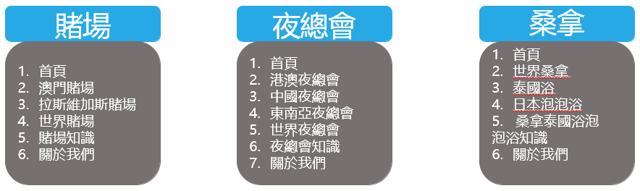
可根據上述文章做試排版，上圖提供參考做撰寫企劃

