https://www.facebook.com/profile.php?id=100008203661834&fref=nf
看起來不像孔雀魚 字體死板
https://www.facebook.com/photo.php?fbid=376365095819394&set=a.112868388835734.14771.100003377215194&type=1&source=11
https://www.facebook.com/joe.putta?fref=nf

https://www.facebook.com/PhilippineGEES
頗有設計感 不過整體感太細 感覺有些空洞
https://www.facebook.com/photo.php?fbid=551118728288465&set=a.103056929761316.4333.100001710280353&type=1&source=11

有種復古手作感

https://www.facebook.com/photo.php?fbid=353623811448831&set=a.113768895434325.23489.100004036465974&type=1&theater
https://www.facebook.com/photo.php?fbid=10200365137000130&set=a.1403249730372.2050276.1506218017&type=1&theater

https://www.facebook.com/guppyindonesia?fref=pb&hc_location=friends_tab
https://www.facebook.com/photo.php?fbid=587199131303328&set=a.148752425148003.27520.100000397381713&type=1&theater

https://www.facebook.com/photo.php?fbid=543629255695177&set=a.110956148962492.9048.100001443217474&type=1&theater
https://www.facebook.com/photo.php?fbid=567820769922997&set=a.147151245323287.20998.100000852375031&type=1&theater
https://www.facebook.com/pandoras.guppy?fref=pb&hc_location=friends_tab
https://www.facebook.com/photo.php?fbid=10202273205465021&set=a.1497279245423.75073.1637396593&type=1&theater
https://www.facebook.com/photo.php?fbid=10152106977967440&set=a.10150101105542440.273725.716482439&type=1&theater
https://www.facebook.com/photo.php?fbid=516557091787758&set=a.102604149849723.5181.100003004152720&type=1&source=11
https://www.facebook.com/photo.php?fbid=1387010204855622&set=a.1384329181790391.1073741826.100006399669301&type=1&theater
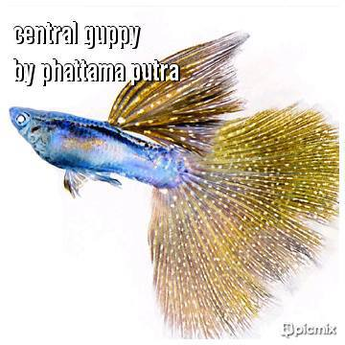
https://www.facebook.com/photo.php?fbid=1422027648013998&set=a.1375666055983491.1073741824.100006203283897&type=1&theater
https://www.facebook.com/photo.php?fbid=105081246358905&set=a.105081243025572.1073741826.100005710895602&type=1&theater
https://www.facebook.com/photo.php?fbid=345597425562474&set=a.345597422229141.1073741825.100003366579986&type=1&theater
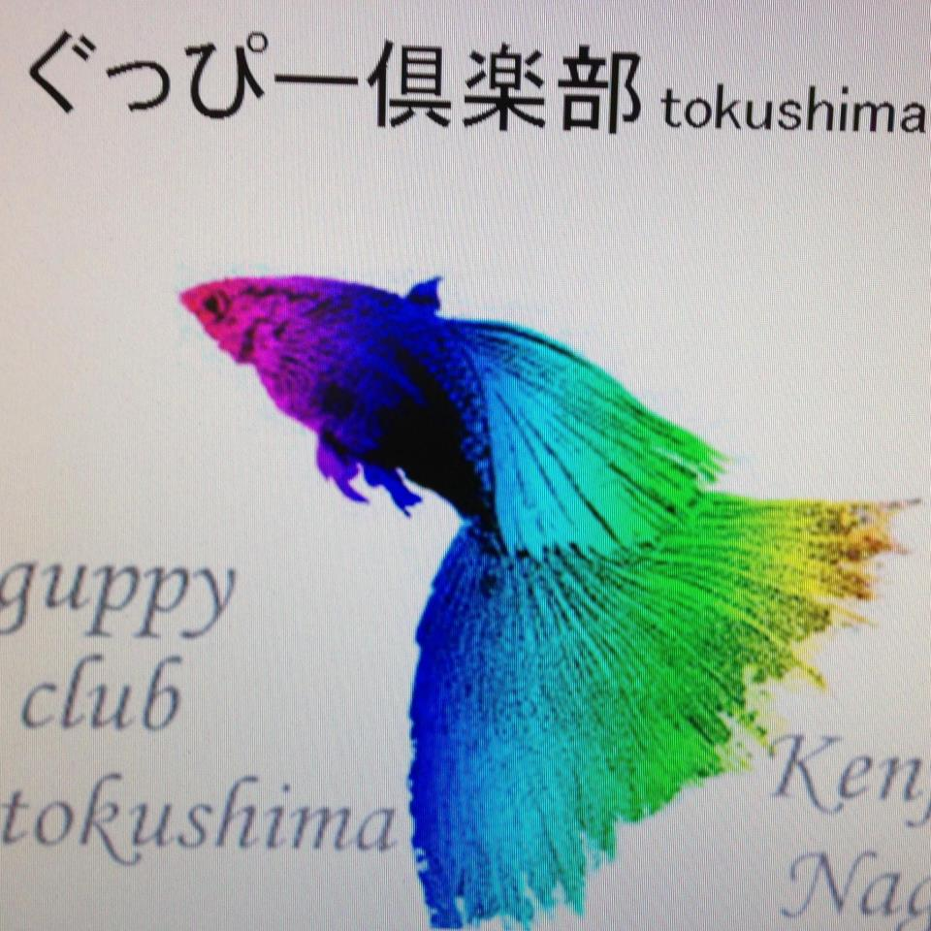
https://www.facebook.com/photo.php?fbid=294615384030808&set=a.104232936402388.10760.100004470456195&type=1&theater
https://www.facebook.com/photo.php?fbid=349033415165838&set=a.110784058990776.11238.100001775465931&type=1&theater

