正面
Instant Face Lift Serum

With collagen & Peptides

15ml
背面
Ingredients: Purified Water, Sodium silicate, Magnesium Aluminum silicate, Propylene Glycol, Sodium Carboxymethyl cellulose, Collagen, Palmitoyl Oligopeptide, Palmitoyl Oligopeptide-7, Phenoxyethanol, Ethlhexyglycerin

Directions: Shake well. Apply to fingertip and smooth over wrinkles on forehead, around eyes(SEE CAUTION BELOW). Or any other areas. Blend off the ends with a damp tissues. Do not rub. Allow to dry and thoroughly and apply water or mineral based makeup as usual.

Caution: Do not use on eyelids. If contact with eyes should occur. Flush with cool water. If any form of irritation occurs, discontinue use.

Manufactured By:
Epilift Anti-Aging Solutions
Naples, FL 34114, U.S.A
www.Epilift.com
Made in USA

Not tested on Animals.

Please Recycle.

正面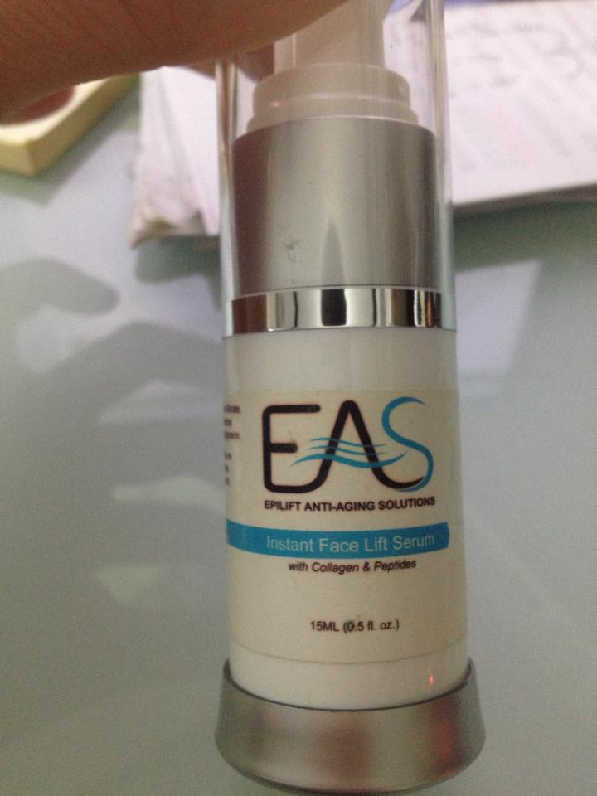

背面
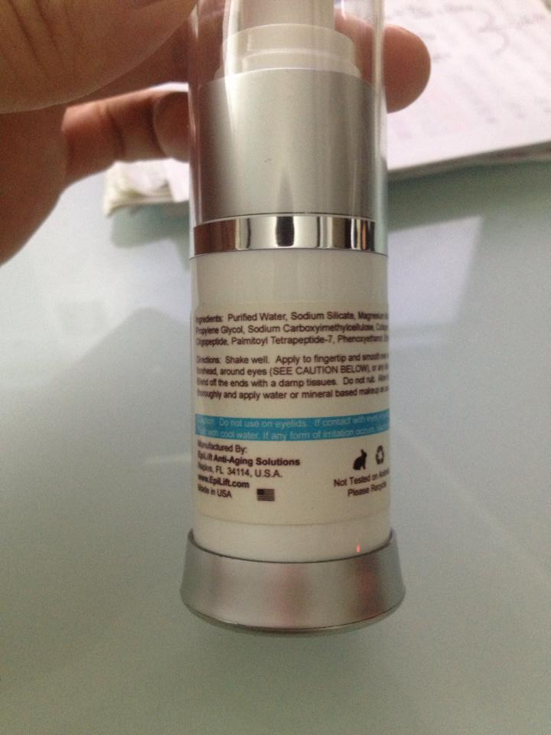

側面